**PIZZA SALES SQL QUERIES**

**A. KPI’s**

**1. Total Revenue:**

SELECT ROUND(SUM(od.quantity * p.price), 2) AS total_revenue

FROM order_details od

JOIN pizzas p ON od.pizza_id = p.pizza_id;

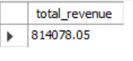

**2. Average Order Value**

select (sum(p.price) / count(distinct o.order_id)) as Avg_order_Value from orders o

JOIN order_details od ON o.order_id = od.order_id

JOIN pizzas p ON od.pizza_id = p.pizza_id;

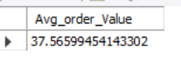

**3. Total Pizzas Sold**

SELECT SUM(quantity) AS total_pizzas_sold

FROM order_details;

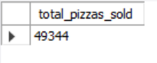

**4. Total Orders**

select count(*) as Total_Orders from orders;

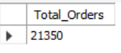

**5. Average Pizzas Per Order**

SELECT ROUND(SUM(od.quantity) / COUNT(DISTINCT o.order_id), 2) AS avg_pizzas_per_order

FROM order_details od

JOIN orders o ON od.order_id = o.order_id;

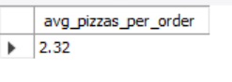

**B. Daily Trend for Total Orders**

SELECT order_day, COUNT(*) AS total_orders

FROM (

SELECT DAYNAME(date) AS order_day

FROM orders

) AS daily_orders

GROUP BY order_day

ORDER BY FIELD(order_day, 'Monday','Tuesday','Wednesday','Thursday','Friday','Saturday','Sunday');

***Output:***

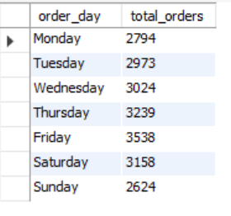

**C. Hourly Trend for Orders**

SELECT order_hour, COUNT(*) AS total_orders

FROM (

SELECT HOUR(time) AS order_hour

FROM orders

) AS hourly_orders

GROUP BY order_hour

ORDER BY order_hour;

***Output***

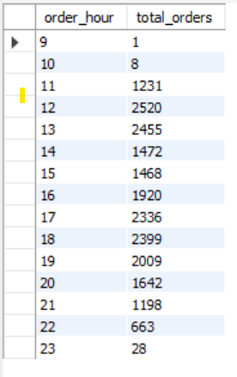

**D. % of Sales by Pizza Category**

SELECT pt.category,

ROUND(SUM(od.quantity * p.price), 2) AS category_revenue,

ROUND(SUM(od.quantity * p.price) * 100 / (

SELECT SUM(od2.quantity * p2.price)

FROM order_details od2

JOIN pizzas p2 ON od2.pizza_id = p2.pizza_id

), 2) AS percentage_of_total_sales

FROM order_details od

JOIN pizzas p ON od.pizza_id = p.pizza_id

JOIN pizza_types pt ON p.pizza_type_id = pt.pizza_type_id

GROUP BY pt.category

ORDER BY percentage_of_total_sales DESC;

***Output***

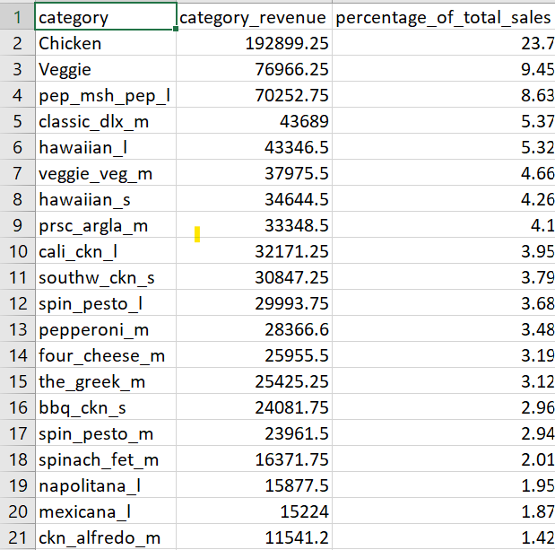

**E. % of Sales by Pizza Size**

SELECT p.size,

ROUND(SUM(od.quantity * p.price), 2) AS size_revenue,

ROUND(SUM(od.quantity * p.price) * 100 / (

SELECT SUM(od2.quantity * p2.price)

FROM order_details od2

JOIN pizzas p2 ON od2.pizza_id = p2.pizza_id

), 2) AS percentage_of_total_sales

FROM order_details od

JOIN pizzas p ON od.pizza_id = p.pizza_id

GROUP BY p.size

ORDER BY percentage_of_total_sales DESC;

***Output***

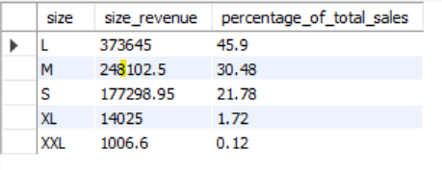

**F. Total Pizzas Sold by Pizza Category**

SELECT pt.category,

SUM(od.quantity) AS total_pizzas_sold

FROM order_details od

JOIN pizzas p ON od.pizza_id = p.pizza_id

JOIN pizza_types pt ON p.pizza_type_id = pt.pizza_type_id

GROUP BY pt.category

ORDER BY total_pizzas_sold DESC;

***Output***

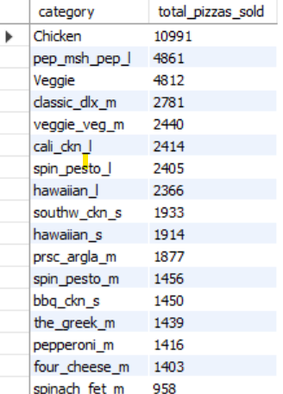

**G. Top 5 Best Sellers by Total Pizzas Sold**

SELECT pt.name AS pizza_name,

SUM(od.quantity) AS total_pizzas_sold

FROM order_details od

JOIN pizzas p ON od.pizza_id = p.pizza_id

JOIN pizza_types pt ON p.pizza_type_id = pt.pizza_type_id

GROUP BY pt.name

ORDER BY total_pizzas_sold DESC

LIMIT 5;

***Output***

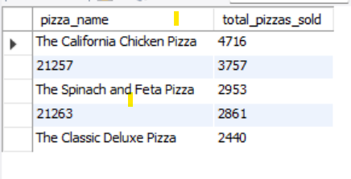

**H. Bottom 5 Best Sellers by Total Pizzas Sold**

SELECT pt.name AS pizza_name,

SUM(od.quantity) AS total_pizzas_sold

FROM order_details od

JOIN pizzas p ON od.pizza_id = p.pizza_id

JOIN pizza_types pt ON p.pizza_type_id = pt.pizza_type_id

GROUP BY pt.name

ORDER BY total_pizzas_sold ASC

LIMIT 5;

***Output***

